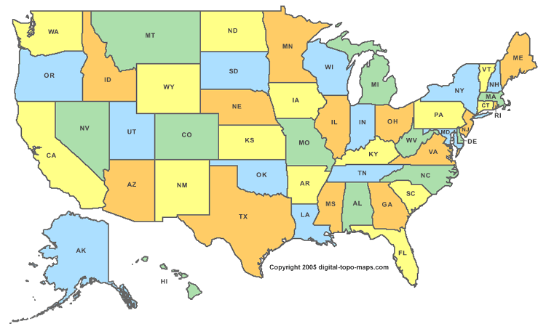
NATIVE AMERICAN WEBQUEST
MIAMI
CHEYENNE
APACHE
CREEK
FOX
MOHAWK
CHEROKEE
HAUDENOSAUNEE
SHAWNEE
CHICKASAW
ILLINOIS
COMANCHE
CROW
KAW
LAKOTA
SIOUX
BLACKFOOT
AZTECS
PUEBLO
HOPI
TLINGIT

