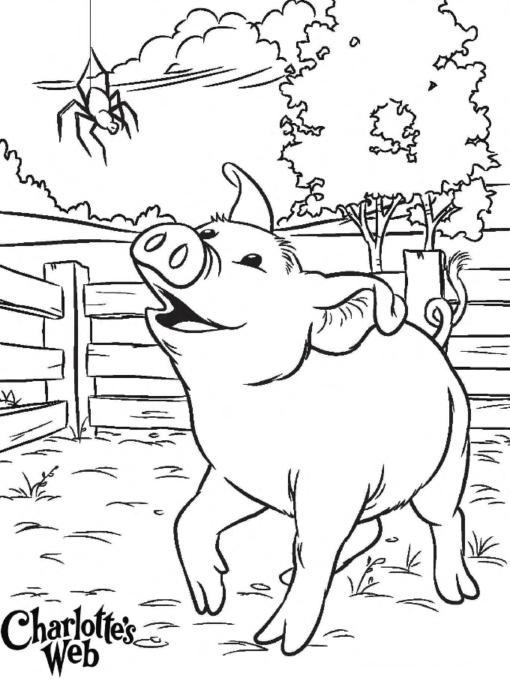

NAME_________________
SPELLING WORDS

NAME_________________
SPELLING WORDS

