FOOD CHAINS AND WEBS TEST (50 pts total)
page 1 only: pre-test NAME ______________
DO YOU KNOW? Choose the correct term from the word bank. (20)
1. An _________________________eats both plants and animals.

2. A _________________________________ makes its own food.

3. An interesting group of organisms is an _____________________.

4. An _____________________ only eats plants or other producers.

5. A ________________________ animal is eaten by a predator.

6. A ________________________________ is what an animal eats.

7. A ___________________________ breaks down organic matter.

8. An __________________________________ is a living thing.

9. A ________________________ eats other organisms.

10. A _________________________ eats meat.

diet herbivore decomposer
prey carnivore producer
ecosystem omnivore
organism consumer
http://www.enchantedlearning.com/subjects/foodchain/

1. Where do plants get the energy they need to produce their food? (2)
a. Animal b. Plant c. Sun d. Water

2. Plants produce their own food, so they are called: (2)
a. Consumers b. Decomposers c. Populations d. Producers

3. Describe the main difference between producers and consumers. (4)

4. Identify which organisms are consumers or producers from the following list(10)
Bermuda grass, woodpecker, beetle, crawdad, cattail, trout, pine tree, water snake, algae, water lily

consumer | producer

5. Number the pictures below to create a food chain. (3)
___

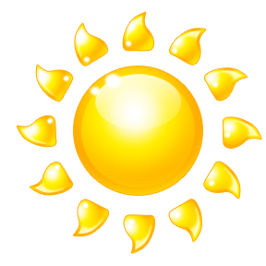

6. Using pictures and words, make an ecosystem food chain with four links based on your research at the creek. (Remember to begin with the _ _ _.) (4)

7. Essay. In 3 or more complete sentences, answer this question. In a creek, algae gets its energy from the sun and provides food for minnows. The minnows are eaten by a trout which is eaten by a turtle. The turtle is eaten by a badger. What could happen if all of the trout died from disease or pollution? (5)

